TIpos de JOINS

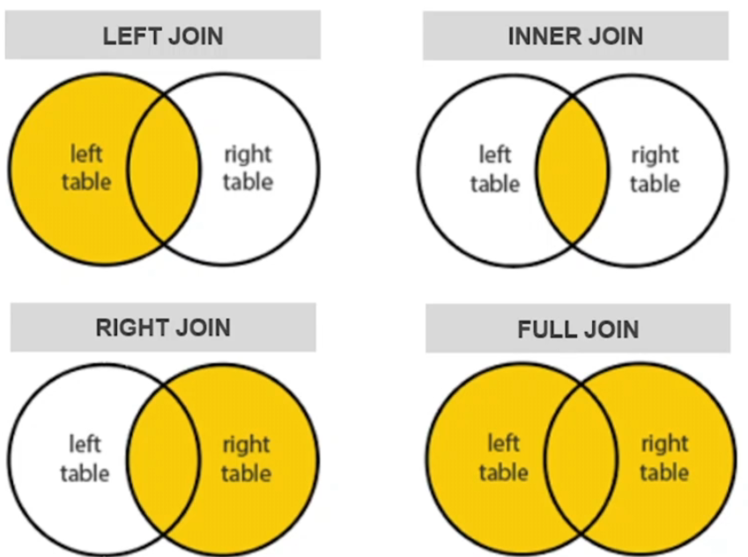

Exemplo 1: Utilize o LEFT JOIN para fazer join entre as tabelas

– temp_tables.tabela_1 e temp_tables.tabela_2

select * from temp_tables.tabela_1

select * from temp_tables.tabela_2

select t1.cpf, t1.name, t2.state

from temp_tables.tabela_1 as t1 left join temp_tables.tabela_2 as t2

on t1.cpf = t2.cpf

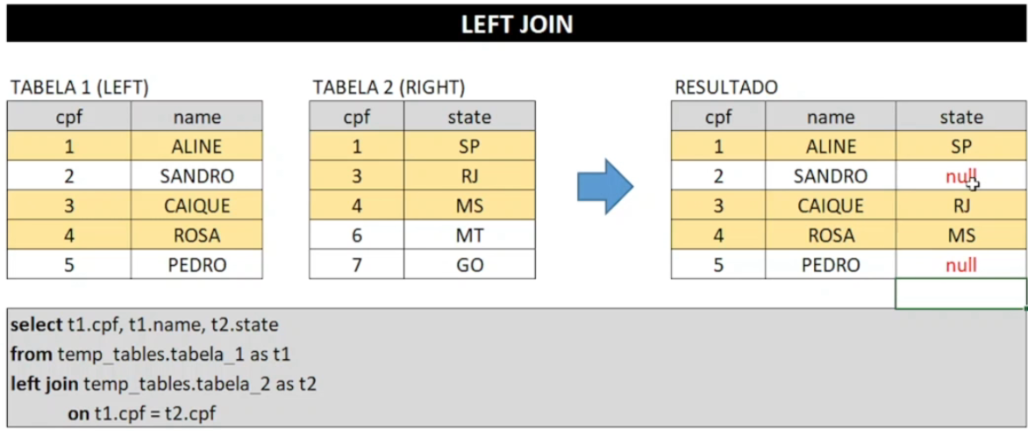

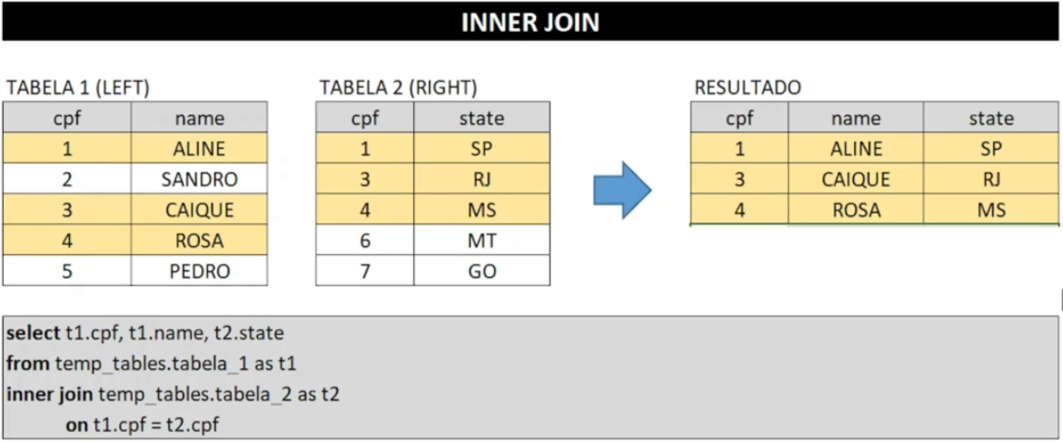

Exemplo 3: Utilize o RIGHT JOIN para fazer join entre as tabelas

– temp_tables.tabela_1 e temp_tables.tabela_2

select t1.cpf, t1.name, t2.state

from temp_tables.tabela_1 as t1

right join temp_tables.tabela_2 as t2

on t1.cpf = t2.cpf

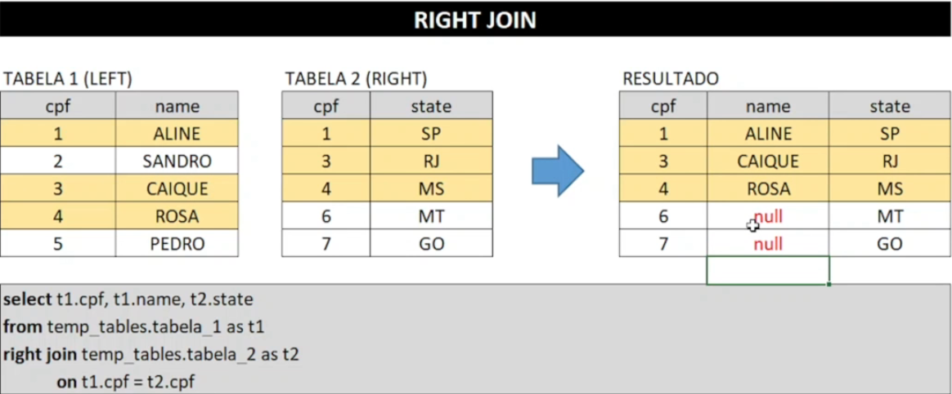

Exemplo 4: Utilize o FULL JOIN para fazer join entre as tabelas

– temp_tables.tabela_1 e temp_tables.tabela_2

select t2.cpf, t1.name, t2.state

from temp_tables.tabela_1 as t1

full join temp_tables.tabela_2 as t2

on t1.cpf = t2.cpf

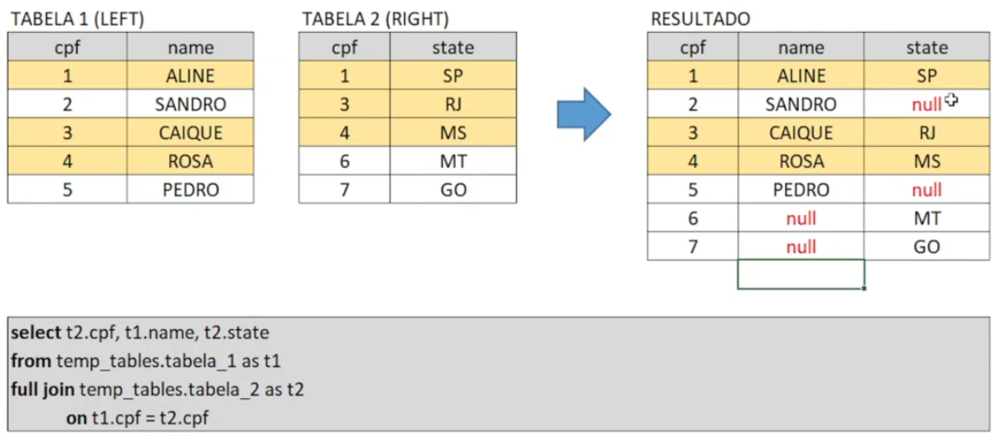

Exemplos :

1. Identifique qual é o status profissional mais frequente nos clientes que compraram automóveis em nosso site

select cus.professional_status,

count (fun.paid_date) as pagamentos

from sales.funnel as fun

left join sales.customers as cus

on fun.customer_id = cus.customer_id

group by cus.professional_status

order by pagamentos desc

1. Identifique qual é o gênero mais frequente nos clientes que compraram automóveis no site. OBG: utilizar a tabela temp_tabela.ibge_genders

select * from temp_tabela.ibge_genders limit 10

select ibge-gender, count(fun.paid_date)

from sales.funnel as fun

left join sales.customers as cus

on fun.customer_id = cus.customer_id

left join temp_tables.igbe_genders as ibge

on lower(cus.first_name) = ibge.first_name

group by ibge.gender

1. Identifique de quais regiões são os clientes que mais visitam o site

* utilizar a tabela temp_tables.regions

select * from sales.customers limit 10

select * from temp_tables.regions limit 10

from sales.funnel as fun

left join sales.customers as cus

on fun.customer_id = cus.customer_id

left join temp_tables.regions as reg

on lower(cus.city) = lower(reg.city)

and lower(cus.state) = lower(reg.state)

group by reg.region

order by visitar desc